# CS 255 System Design Document

## UML Diagrams

### UML Use Case Diagram

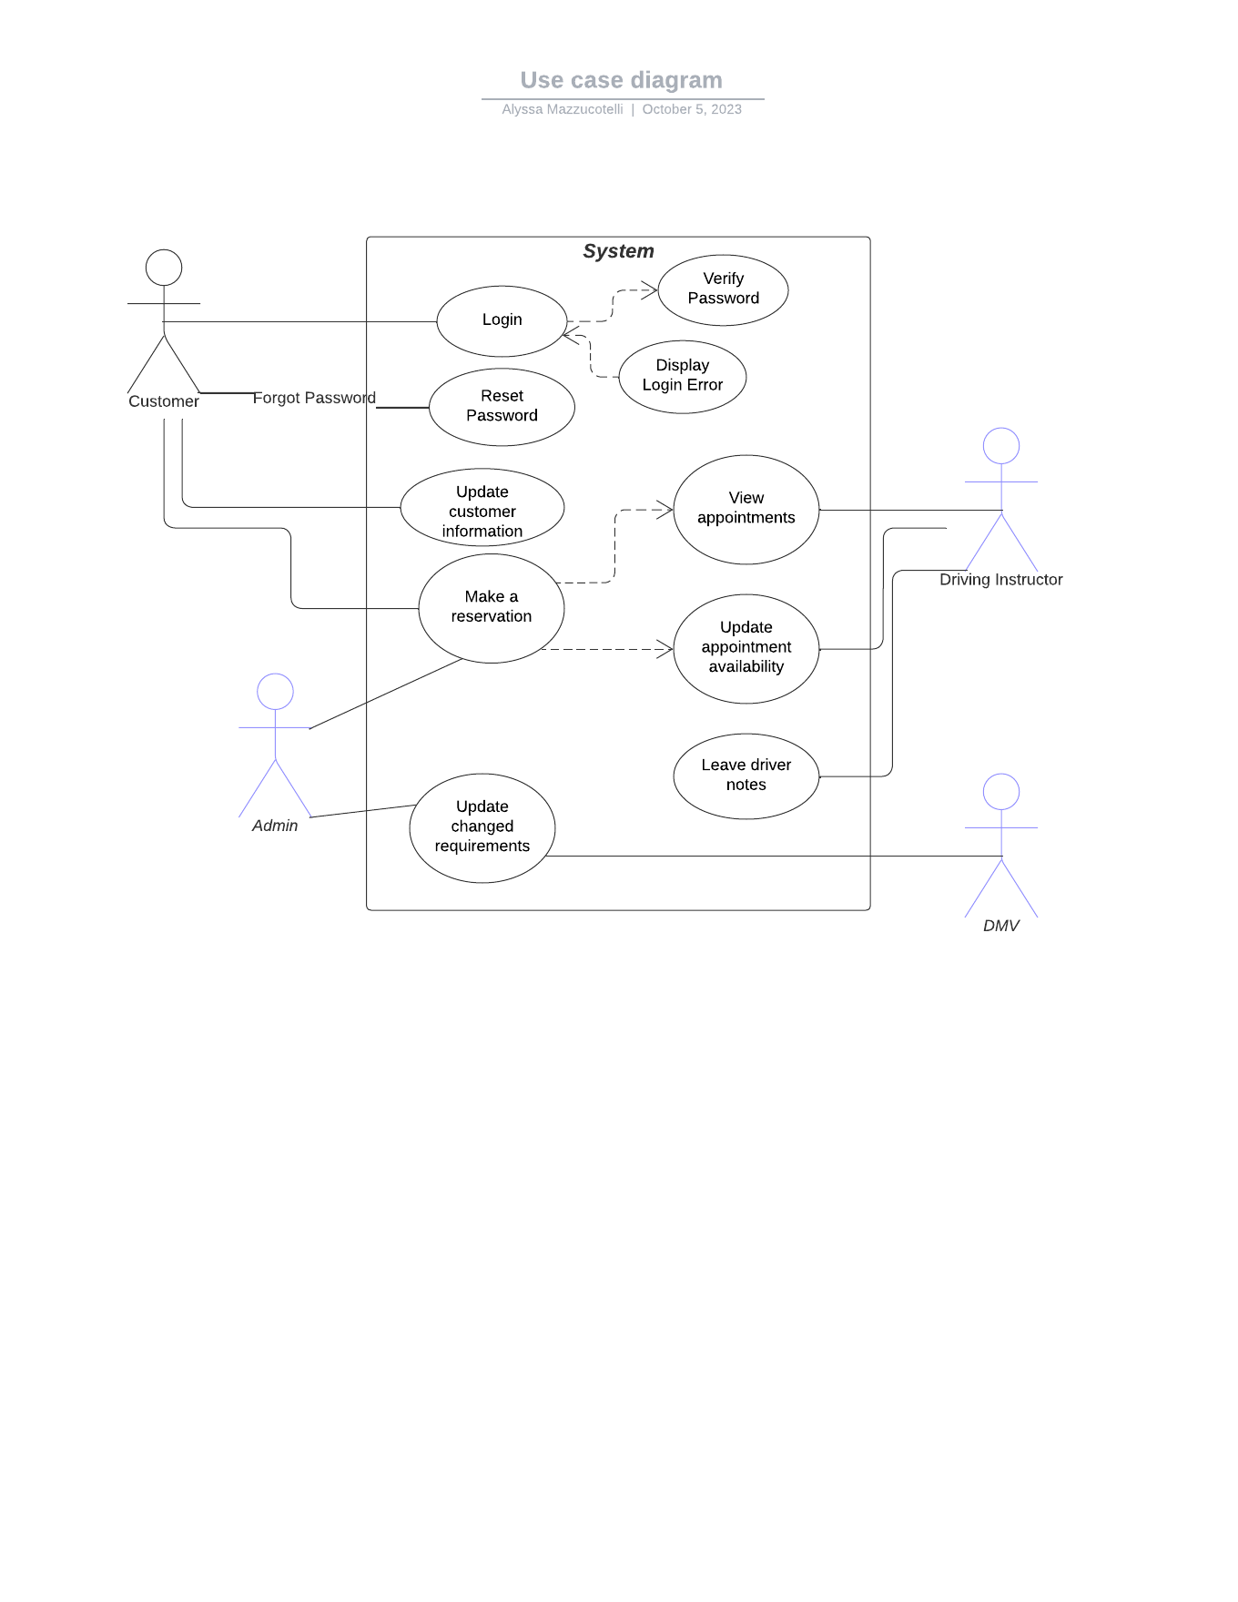

### UML Activity Diagrams

### UML Sequence Diagram

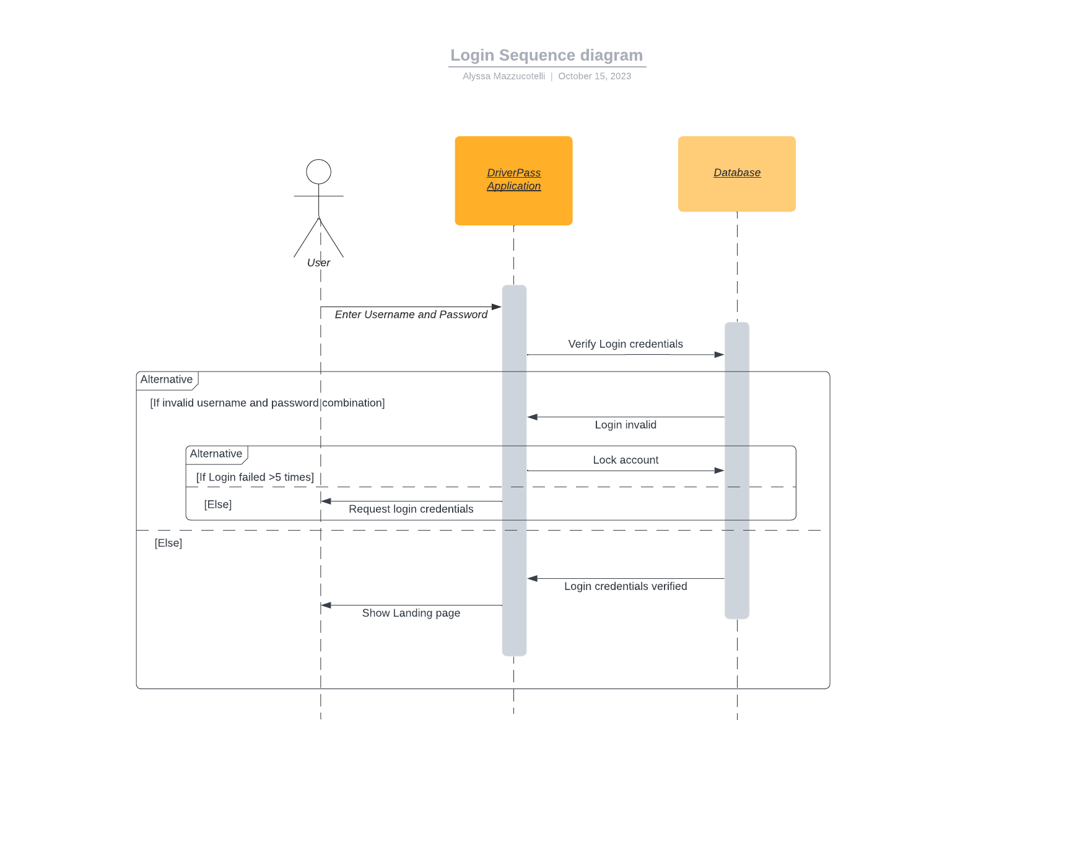

## Technical Requirements

Some technical requirements for this system include the need for each user to have access to the internet and some form of internet browser. Some things needed to run the application also include things like a database to store login information and a database to store the reservations. There would also be a need for a server to run the application. On the teaching side there would also be a need for instructors as well as cars.